

s
Updated at: https://github.com/knebiolo/stryke

Stryke currently functions as either a webapp or desktop app. Please see the project github page for installation instructions for the desktop app. The webapp functions from a browser and does not require installation.
Stryke User Guide

Prepared by:
Kleinschmidt Associates

April 2025

Table of Contents
Report Title

Name of Hydroelectric Project
(if applicable)

FERC No. XXXXX (if applicable)

Prepared for:
Client Name

Prepared by:
Kleinschmidt Associates

Month Year

1.0 Stryke Introduction 1
2.0 Fit Entrainment Rates 3
3.0 Web Application 5
3.1 Create New Project 6
3.2 Flow Scenarios 6
3.3 Facility Information 6
3.4 Unit Parameters 7
3.5 Operating Scenarios 7
3.6 Population Parameters 7
3.7 Graph Data (Migratory Route Creation) 8
3.8 Simulation Outputs 8
4.0 Spreadsheet Interface 9
4.1 Flow Scenarios 9
4.2 Hydrology 10
4.3 Facilities 11
4.4 Unit Parameters 12
4.5 Operating Scenarios 13
4.6 Nodes and Edges 15
4.7 Population 16
4.8 Simulation Outputs 18
5.0 Example Workflow #1: Station 1 20
5.1.1 Step 1: Create New Project. 20
5.1.2 Step 2: Flow Scenarios 21
5.1.3 Step 3: Facilities 22
5.1.4 Step 4: Unit Parameters 23
5.1.5 Step 5: Operating Scenarios 24
5.1.6 Step 6: Migratory Route Creation 25
5.1.7 Step 7: Population Parameters 26
5.1.8 Step 7: Model Setup Summary 27
5.1.9 Step 8: Simulation Progress 28
5.1.10 Step 9: Examine Results 29
6.0 Example Workflow #2: Coniston 31
6.1.1 Step 1: Create New Project. 31
6.1.2 Step 2: Flow Scenarios 32
6.1.3 Step 3: Facilities 33
6.1.4 Step 4: Unit Parameters 35
6.1.5 Step 5: Operating Scenarios 36
6.1.6 Step 6: Migratory Route Creation 37
6.1.7 Step 7: Population Parameters 38
6.1.8 Step 7: Model Setup Summary 39
6.1.9 Step 8: Simulation Progress 41
6.1.10 Step 9: Examine Results 42

https://us-partner-integrations.egnyte.com/msoffice/wopi/files/70c4d9c3-c974-4599-8a00-3585989cb4dc/WOPIServiceId_TP_EGNYTE_PLUS/WOPIUserId_126.kleinschmidt.egnyte.com/STRYKE Readme_D2_04-03-2025.docx

Stryke Introduction
Fish entrained through hydroelectric facilities are exposed to turbine passage mortality stressors. Mortality through hydroelectric turbines has been well studied, with mathematical models able to predict the probability fish will get struck by a turbine blade (Von Raben 1957, Franke et al. 1997). The rate at which fish are entrained (fish per unit volume of water; in the US – fish per million [M] cubic feet [ft3] of water) through hydroelectric facilities is also a well-studied phenomenon in the United States, with results from field trials contributing to an entrainment database compiled by the Electric Power Research Institute (EPRI 1997). The 1997 EPRI database contains observations of 70 species at 43 facilities within the United States east of the Mississippi River. The EPRI dataset is particularly useful for quantitative analysis based on the assumption that when entrainment counts are standardized by discharge across facilities and holistically observed, the database will reasonably estimate entrainment rates for a watershed of a given size suitable for decision-making purposes. Also, by describing entrainment rates with statistical distributions and simulating them with Monte Carlo methods, it is possible to estimate average daily entrainment and mortality with measures of certainty, as well as estimate the likelihood that an event of a given size will occur.

Simulated fish migrate through a hydroelectric project where passage routes are described with a network. We assume all simulated fish will move downstream as they approach the project. If fish survive their current node, they can move to the next one. If there is more than one node available at their current location, then Monte-Carlo role of the dice and a priori-determined transition probabilities control their movement. The simulation ends for a fish when it arrives at the last node in the network or dies.

For fish passing via entrainment, individuals are exposed to turbine blade strike, which is modeled with the Franke et al. (1997) equations. For fish that pass via passage structures or spill, mortality is assessed with a roll of the dice using survival metrics determined a priori, sourced from similar studies, or from expert opinion. The Franke et al. (1997) equations calculate the probability a fish of a given length will get struck by a turbine runner blade. With these equations, if we know the length of a given fish, the amount of discharge through the turbine, the type of turbine, the number of blades, and rotation speed, then we can calculate with certainty the probability of the fish being struck. As such, the only morphometric parameter needed to assess blade strike is length. All other input parameters are sourced from the technical specifications of the facility and its turbines.

This document will guide the end user through an assessment of the effects of entrainment at a hydroelectric facility. The document has directions for setting up a project using the input spreadsheet or with the web application project. Stryke has two modes of operation for two different types of desktop entrainment studies. It can be used to (1) assess survival of anadromous species as they migrate past a facility (or series of facilities), and (2) estimate entrainment rates and survival of resident species to assess population-level impacts attributed to entrainment through a hydroelectric station.

Fit Entrainment Rates
Estimating the number of fish impacted starts with fitting entrainment rates for the species of interest. If you do not have existing empirical data for your facility of interest, stryke can query the EPRI entrainment database and develop them for you. To fit a distribution, simply pass a list of arguments (example below). The list of arguments, their datatype, and explanations are below. The following example shows how to fit entrainment rates for a leave-one-out validation exercise, it queries the EPRI database to return a sample of entrainment observations of Catastomidae in the winter within The Great Lakes watershed while leaving out Potato Rapids from the sample:

Family = 'Catostomidae', Month = [1,2,12], HUC02= [4], NIDID= 'WI00757'
Parameter | Data Type | Comment
states | String | (not required) State abbreviations to filter the data
plant_cap | String | (not required) Plant capacity (cfs) with a direction for filtering (> or <=)
Family, Genus, Species | String | (at least one required) taxonomic classifications
HUC02, HUC04, HUC06, HUC08 | String | (not required) Hydrologic Unit Codes for geographic filtering, Great Lakes HUC02 = 04.
NIDID | String | (not required) National Inventory of Dams identifier - used to filter out a facility
River | String | (not required) River name for filtering

There may not be enough data to properly estimate uncertainty in a species specific query. In these instances you will need to sacrifice taxonomic, temporal, or spatial precision. Stryke can query Family and Genus, and the list of each found in the EPRI dataset s below.
If no data is returned, check your spelling.

List of Available Families:
Acipenseridae, Amiidae, Anguillidae, Atherinopsidae, Catostomidae, Centrarchidae, Clupeidae, Cottidae, Cyprinidae, Esocidae, Fundulidae, Gasterosteidae, Ictaluridae, Lepisosteidae, Lotidae, Moronidae, Osmeridae, Percidae, Percopsidae, Petromyzontiformes, Salmonidae, Sciaenidae, Umbridae

List of Available Genus:
Acipenser, Alosa, Ambloplites, Ameiurus, Amia, Ammocrypta, Anguilla, Aplodinotus, Campostoma, Carassius, Carpiodes, Catostomus, Chrosomus, Coregonus, Cottus, Couesius, Culaea, Cyprinella, Cyprinus, Dorosoma, Erimyzon, Esox, Etheostoma, Exoglossum, Fundulus, Gasterosteus, Hybognathus, Hypentelium, Hypomesus, Ichthyomyzon, Ictalurus, Labidesthes, Lampetra, Lepisosteus, Lepomis, Lethenteron, Lota, Luxilus, Margariscus, Micropterus, Minytrema, Morone, Moxostoma, Nacomis, Nocomis, Notemigonus, Notropis, Noturus, Oncorhynchus, Opsopoeodus, Osmerus, Perca, Percina, Percopsis, Petromyzon, Pimephales, Pomoxis, Pylodictis, Rhinichthys, Salmo, Salmonidae, Salvelinus, Sander, Semotilus, Umbra
It is recommended that end users identify species and fit distributions with consultation from resource agencies.

The United States Geological Service defined hydrologic regions within the United States and developed a hierarchical identification system known as Hydrologic Unit Codes (HUCS). The EPRI entrainment dataset has HUC02, HUC04, HUC06 and HUC08 tiers, which delineate hydrologic regions from a large-scale basin level, to the smallest catchment level. The major basins of the United States are defined at the HUC02 level.
- HUC02-02 Mid-Atlantic
- HUC02-03 Southeastern United States
- HUC02-04 The Great Lakes
- HUC02-05 The Ohio River
- HUC02-07 The Mississippi River

When an EPRI query is passed (e.g. fish = stryke.epri(Genus = 'Micropterus', Month = [3,4,5], HUC02 = [2])), stryke will return a figure with four histograms that depict natural logarithm transformed entrainment rates (one observed, three simulated). Stryke fits a Log Normal, Weibull, and Pareto distribution to the returned data and produces a p-value from a Kolmogorov-Smirnov test, where H0 = no difference between observed and simulated histogram. The distribution with the largest p-value best describes trends in observed data. The query above produced the figure below. In this instance, the Log Normal had the highest p-value and is most like the observed data. For most queries, the Log Normal will be the best distribution. The Weibull is best one of the tails is heavier than the other, and the Pareto only works in special cases when observations are monotonically decreasing after log transforming them.

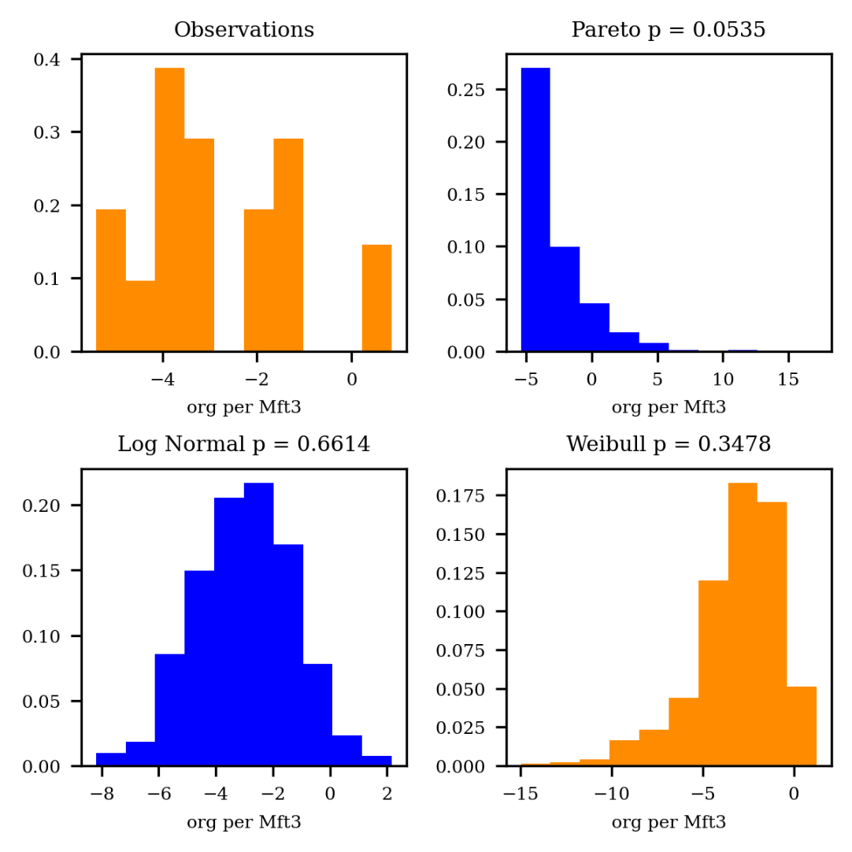

The end user then inputs the parameters from the best performing distribution into the input spreadsheet.

Web Application
Stryke has been adapted to work with a convenient web application. This allows users to run a complete simulation from a browser and interact with a user interface.
To access the stryke web application users should visit:
https://stryke-production.up.railway.app/login
Currently the web application consists of six pages (Facilities, unit parameters, operating scenarios, population parameters, flow scenarios and graph data (migratory route creation). All units in the web application are metric, and are either in units of meters or cubic meters per second unless otherwise expressed. When using the web application, users can hover over the [?] icons to display additional information about each field.
Important: Users must logout of the web application between simulation runs to reset the tool and clear the cache. Failure to do this may result in errors and corrupted results.

Create New Project
This step tracks information about the project, including model metadata and setup. There are four model setup scenarios to choose from:
- Specified single unit, survival only
- Specified single unit, simulated entrainment with survival, no movement
- Single powerhouse with movement, simulated entrainment with survival
- Multiple dependent powerhouses with movement, simulated entrainment with survival
The first two model modes are for single units that use unit-specific discharge rates (m³/s), while the second two model modes use river discharge and route fish through or around the powerhouse(s).

Flow Scenarios
On this page, you’ll define a “flow scenario” for your project. A flow scenario can represent a single, steady flow rate (a static scenario), or a set of daily/monthly flows you paste in from a spreadsheet or text file (a hydrograph). Give each scenario a descriptive name, pick the time of year (season/months) it covers, and specify whether you want a constant discharge or to upload a hydrograph. If you choose a hydrograph, simply paste your data without headers into the indicated box, and the software will use that varying flow throughout the model runs. Once you’re done, click “Save Scenario” to move on.

Facility Information
On this page, you’ll define the generating station(s) in your model. For each powerhouse, you’ll provide its name, minimum required flow for operation, the number of turbine units you will be simulating, and any additional flow needed for the environment releases or downstream bypass devices. You can also specify the rack spacing (mm) and whether the facility has a spillway. If your intent is to model survival and/or entrainment at a specific unit, then do not identify a spillway, and you will enter 0 for minimum operating flow, environmental flow, bypass flow. The model assumes the hydrograph you provide is representative of the amount of discharge that has passed through the specific unit. This information helps the model understand each station’s seasonal operational constraints and capacity. When finished, click “Save Facilities” to move on to setting up unit-specific parameters.

Unit Parameters
On this page, you’ll provide details for each turbine unit within your selected generating station(s). For example, you’ll specify the runner type, flow capacity, through-rack intake velocity, and other relevant fields. If you’re unsure about the units, hover over the little info icons for more guidance.

The lambda value is used to correlate blade strike calculations with instantaneous mortality. To account for latent mortality the lambda value can be increased proportional to published latent mortality rates for a given species. For example, if a lambda of 0.2 produces 95% survival, and latent survival following blade strike is 80%, lambda would be adjusted to 0.35.

If you are simulating multiple units with identical parameters, you can click the blue “Copy From Previous Unit” button to populate the field in the subsequent units using the data from the previous unit. Once you finish entering these parameters, click “Save Unit Parameters” to move on to the next step.

Operating Scenarios
On this page, you’ll describe how each turbine unit operates over time. For a run-of-river facility, you might run at a steady rate all day (24 hours); for a peaking or pumped-storage facility, you might operate only during certain hours. If you are simulating the latter, you will see new fields: “Prob Operating,” and shape parameters (Shape, Location, Scale). For advanced users modeling pumped storage or peaking, it is possible to simulate operations with a hurdle model. Where the first draw simulates whether or not the unit is operating (Prob Operating), and if operating, the second draw simulates the number of hours operated per day (log normal shape parameters). However, for most applications and beginners it is recommended to enter the number of hours the unit is expected to operate per day for that season and disregard these new fields. If you’re unsure about any field hover over the small info icons for more details. When you’re done, click “Save Operating Scenarios” to move on.

Population Parameters
On this page, you’ll set up the fish population for your model. Enter the species scientific name, common name, and then the number of iterations you wish to have in your model. Next, there are two fields that control the barotrauma assessment; Vertical Habitat Preference and Swim Bladder Type. For vertical habitat preference choose pelagic or benthic. This field controls the fish’s acclimation depth. For Swim Bladder Type, choose Physoclistous or Physostomous fish. Physoclistous fish do not have a duct on their swim bladder and cannot expel gasses like Physostomous fish can. Therefore, they are more at risk to barotrauma than Physostomous fish and have a different biological response model. Then you will choose to simulate an Entrainment Event or Starting Population. To estimate the number of fish impacted, choose Entrainment Event. If you just want survival, enter in a Starting Population. For Entrainment Rates, choose Modeled or Empirical. Advanced users can choose “Empirical” and enter in their own distribution parameters. However, for beginners it is recommended that users choose Modeled Entrainment Rates. Then, it is possible to select a species/scenario of interest. If you need help with any input (like “Ucrit”), just hover over the info icons for more details. After saving, you’ll see these population details in your final results.

Note: Entering data into the “Length Overrides” fields will override the data from the EPRI entrainment dataset.

Graph Data (Migratory Route Creation)
On this page, you will lay out a simple “map” (or network) showing how fish migrate through your facility. For a single-unit model, you will only need a single location — representing the turbine. If you’re modeling more complex setups, you can add extra nodes (like “Spillway” or “Bypass” or other units) and connect them with edges to show the paths fish might take. Each node has an associated survival rate or function. When you’re finished, click “Save Graph” to confirm these connections.
Note: if you are unable to see nodes and edges within the workspace on the Migratory Route Creation page users should press back and forward on the browser, this will reload the page and clear any nodes or edges entered.

Simulation Outputs
Upon completion of the model iterations, the Simulation Progress page will show some results, including the mean survival rate with confidence intervals and the average number of fish entrained per season and average number of mortalities per season. Press the View Results button to view a complete model output. The first section contains model metadata. The second section plots the histogram if provided. The Beta Distribution section describes the average survival rate with confidence interval. The next section performs a Seasonal Summary, which includes the average number entrained and average mortality per season as well as some likelihoods. The final section plots daily histograms for the number entrained and number of mortalities. Note, a majority of the observations are small or zero. However, large entrainment events are expected to occur.

Spreadsheet Interface
There are two ways that you can set up and run a desktop entrainment study, a web interface with UI, or via Input Spreadsheet. The input spreadsheet allows the end user to run more than 1 species and/or more than 1 flow scenarios. Stryke will need data describing river discharge scenarios, project operating scenarios, seasonal entrainment events, turbine parameters, and migratory routes. There is a tab for each major study component; you can find directions to complete them below. It is possible to configure a Stryke project (spreadsheet) for resident or anadromous species impact assessments, for different operating configurations (run of river, peaking, and pumped storage operations), and it allows for an expanded migratory network with multiple dependent facilities.

NOTE: Stryke will not overwrite output tabs in the spreadsheet interface. Therefore, ensure that the input spreadsheet does not contain pre-existing output before running a new simulation. After running a simulation, it is advisable to save the input file with output tabs so that simulation parameters and outputs are contained in a single file and subsequent simulations should start with different spreadsheets.

The input spreadsheet and this User Guide are in the order in which parameters should be entered. You will note that the spreadsheet makes use of pull-down lists for ease of data entry and for maintaining consistent naming conventions across individual sheets.

Flow Scenarios
This section contains instructions for setting up the ‘Flow Scenarios’ tab on the spreadsheet interface. There are different setups for resident and anadromous species; therefore, it is advised that they be analyzed separately. For resident species, entrainment events often occur on a seasonal cycle and are a function of the amount of water discharged through a facility. The intent of Stryke is to simulate over the range of potential river discharges and realistic plant operating scenarios. For facilities with multiple units, it is assumed that a single unit would be operated until its most efficient flow. At that point, water will then begin to flow through the other units until their most efficient flow or until the hydraulic capacity of the facility is met. Additional discharge beyond the facility's capacity is then spilled over the dam. Assuming fish proportionally follow the flow, we can estimate the rates at which fish will pass via each passage route. Thus, if we know the river discharge and hydraulic capacities of the unit(s), we can simulate passage through the facility.

On the Flow Scenarios tab, you will note the following columns: Scenario Number, Scenario, Flow, Gage, FlowYear, Prorate, Season, Months. An explanation of the columns, expected data types, and strategies for native species is in the table below.

Field | Data Type | Comment
Scenario Number | Integer | (required) scenario number. must be unique
Scenario | String | (required) name of scenario, not more than 50 characters
Flow | String | (required) value must be 'hydrograph' or a discharge, e.g. 50 m³/s
Prorate | Float | (required) project watershed area to the watershed area that contributed to the hydrograph, if unknown use default (1.)
Season | String | (required) hydrologic season, e.g. winter
Months | List | (required) list of calendar months that make up a hydrologic season, values separated by commas

When set up properly, the Flow Scenarios tab should look like the following image. Note, we are using meteorological seasons as our hydrologic seasons. However, this isn't required. You can use any season as long as it is a list of integers separated by commas.

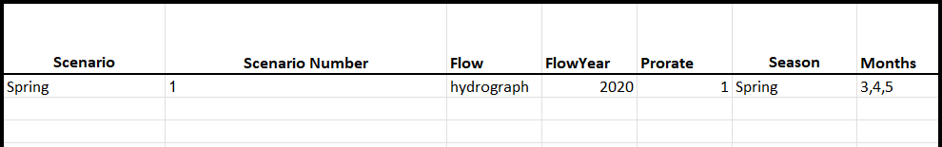

Hydrology
If they indicate ‘hydrograph’ on the Flow Scenarios tab, users must provide their own. The data must consist of two columns, a Date (YYYY-MM-DD) and a Discharge (m³/s) column. Headers are not necessary. Once formatted in Excel, the end user simply copies and pastes the data from Excel into the two columns. The end user does not have to use an existing, historical hydrograph; they can use a simulated hydrograph to study different flow scenarios, including hydrologic changes the result of climate change.

Field | Data Type | Comment
Date | DateTime | (required) Excel formatted data, on import into stryke all date formats converted to YYYY-MM-DD format
Discharge | Float | (required) daily average discharge in m³/s

Below is a screenshot of the hydrology tab from within the input spreadsheet.
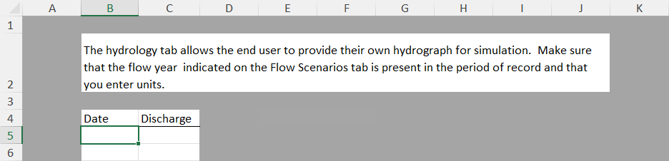

Facilities
Stryke is capable of simulating survival and movement through a complex migratory network that can include multiple dependent facilities. The Facilities tab contains information describing operations and seasonal minimum flow releases for each simulated powerhouse.

Field | Data Type | Comment
Facility | String | (required) Facility/Powerhouse name. must be unique
Season | String | (required) hydrologic season, must be listed on Flow Scenarios tab
Operations | String | (required) pull down, choose between 'run-of-river', 'pumped storage', or 'peaking'
Min_Op_Flow | Float | (required) minimum operating discharge, if unknown enter 0
Env_Flow | Float | (required) minimum release discharge, if unknown enter 0
Bypass_Flow | Float | (required) minimum discharge through downstream bypass structure, if unknown enter 0
Spillway | String | (required) spillway that services a particular facility

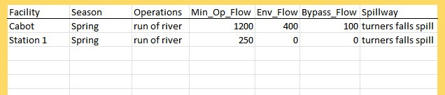

Unit Parameters
The unit parameters tab contains measurable properties of the project's turbines and facilities such hydraulic head, runner diameter, number of blades, etc., to implement the Franke blade strike calculations. Note not all parameters are required for all turbine types.

Field | Data Type | Comment
Unit | String | (required) unit identifier, must match identifiers used on Nodes, Edges, and Operating Scenarios tab
Runner Type | String | (required) type of runner, must be one of (Kaplan, Francis, or Propeller)
intake_vel | Float | (required) intake velocity in m/s
op_order | Integer | (required) Preferred operating order of turbines
H | Float | (required) Hydraulic head (m)
RPM | Float | (required) runner revolutions per minute at maximum efficiency
D | Float | (required) runner diameter (m)
η | Float | (required) turbine efficiency (%)
N | Integer | (required) number of buckets or blades
Qopt | Float | (required) most efficient discharge (m³/s)
Qcap | Float | (required) hydraulic capacity of unit (m³/s)
Qper | Float | (not required) percent of capacity at optimum discharge
B | Float | (required - Francis) runner inlet height (m)
ι | Float | (required - Francis) ratio of exit swirl to no exit swirl - leave at 1.1
D1 | Float | (required - Francis) diameter of runner at inlet (m)
D2 | Float | (required - Francis) diameter of runner at outlet (m)
λ | Float | (required) blade strike mortality correlation factor (USFWS recommends 0.2)
roughness | Float | (required) - roughness coefficient of penstock for head loss calculation when calculating acclimation pressure, use default value

Operating Scenarios
The Operating Scenarios tab tells Stryke how to simulate powerhouse operations. Every season and unit combination must be represented in this table. For run-of-river facilities, it is assumed that the facility will run 24/7, whereas a peaking facility or pumped storage facility will run for a different amount of hours every day as demand dictates. The Scenario, Facility, and Unit fields are pull downs to ensure consistent naming conventions across inputs.

Field | Data Type | Comment
Scenario | String | (required) name of hydrologic scenario
Facility | String | (required) the name of each facility in the simulation for which we are estimating entrainment
Unit | String | (required) turbine unit ID, every turbine in the study gets a unique ID
Hours | Integer | (not required) number of hours facility runs every day; if describing with probabilities, leave blank
Prob_Not_Op | Float | (not required, advanced user setting) Binomial probability of facility is not operating
shape | String | (not required, advanced user setting) Scipy Log Normal shape parameter for distribution describing hours operated
location | Float | (not required, advanced user setting) Scipy Log Normal location parameter for distribution describing hours operated
scale | String | (not required, advanced user setting) Scipy Log Normal scale parameter for distribution describing hours operated

The setup for run-of-river facilities is below:
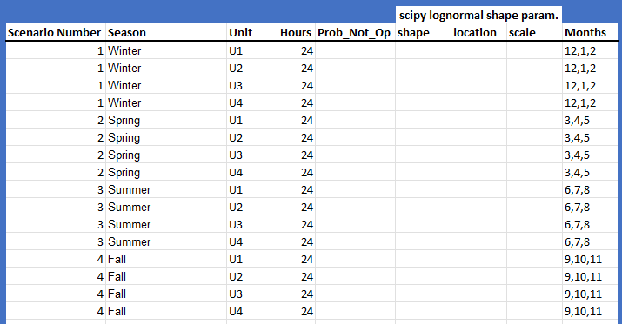
Note, every season and unit combination represented.

The following image depicts Operation Scenarios for peaking and pumped storage projects, which are assumed to operate on demand. Operations at these facilities can be described with a number of hours or two probabilities: the probability that a facility will or will operate, and given that the facility is operating, the probability that a facility will operate for n hours. These parameters are modeled with a binomial and log normal respectively. Note, Stryke requires shape parameters to be fitted with Scipy. These advanced user settings allow for an accurate reconstruction of hours operated per season.

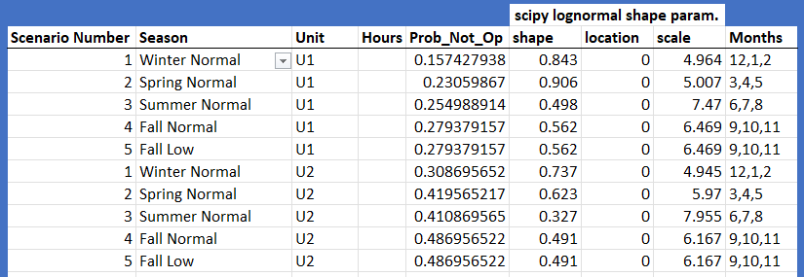

Nodes and Edges
The next two tabs, Nodes and Edges, describe the migratory network simulated fish will move through. Migratory networks are described mathematically with graphs. Nodes are physical locations within the study area, and can include places like: river, forebay, Units, tailrace, spill, etc. Edges are logical migratory pathways that connect nodes together. Stryke always models movements in a downstream direction. The attributes for the Nodes tab are explained below.

Field | Data Type | Comment
Location | String | (required) physical location within the migratory network
Surv_Fun | String | (required) the type of survival function applied at this node, must be 'a-priori' or a Unit ID
Survival | Float | (required) a-prior determined survival rate, if node is a Unit leave 0

The following picture depicts the correct set up for a simple 3-unit run-of-river impact assessment.

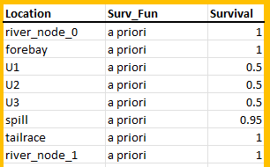

Edges are logical pathways that connect two nodes. Since Stryke simulates movement in one direction (upstream to downstream). Edges are always organized as From Node : To Node.

Field | Data Type | Comment
_from | String | (required) From Node, must match 1 Node from the Nodes tab
_to | String | (required) To Node, must match 1 Node from the Nodes tab
weight | Float | (required) leave as 1.
The following depicts the correct set up for the same, simple 3-unit run-of-river impact assessment. Note: movement is always one way, always downstream.

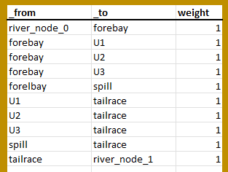

Population
The population tab is the most complex and can be set up for anadromous or resident species. When assessing impact for resident species, entrainment is expressed as a rate (fish per million cubic feet), where the number of fish simulated per day is a function of the river discharge. You can define entrainment rates with your own empirical data, or you can fit them to observations from the EPRI entrainment database, which is included with Stryke. Entrainment rates can be simulated with a Log Normal, Weibull, or Pareto distribution. The maximum entrainment rate (max_ent_rate) is the largest entrainment rate observed. Given that each of these distributions are heavy tailed, the maximum simulated entrainment rate can be very large. Stryke limits the maximum simulated entrainment rate to 1 magnitude larger than the largest observation. Entrainment events are episodic in nature, and it is not likely that there will be an entrainment event every day. Occurrence probability (occur_prob) is the probability of entraining fish of a species on any particular day. Stryke first simulates presence, and if fish are present then simulates an entrainment event (or rate). This entrainment rate is then multiplied by the daily river discharge, and thus a simulated population is created. Once there is a sample population, Stryke simulates fish lengths for each individual in the population. The EPRI entrainment database also supplies information on fish lengths, which Stryke fits a log normal distribution to. The last field required for resident species assessment the critical swim speed or $U_{crit}$. Critical swimming speeds can be sourced from Katapodis and Gervais (2012), which was made available in the literature review.

Field | Data Type | Comment
Common Name | String | (required)
Scientific Name | String | (required)
Season | String | (required) hydrologic season, must be a season on the Operating Scenarios tab
Starting Population | Integer | (not required) number of starting fish in the simulation (for anadromous mode)
(Ent. Event) shape | Float | (not required) shape parameter describing daily entrainment event
(Ent. Event) location | Float | (not required) location parameter describing daily entrainment event
(Ent. Event) scale | Float | (not required) scale parameter describing daily entrainment event.
dist | String | (not required) Distribution type describing daily entrainment event, must be one of (Log Normal, Weibull or Pareto)
max_ent_rate | Float | (not required) maximum entrainment event measured in fish per million cubic metre.
occur_prob | Float | (not required) occurrence probability
iterations | Integer | (required) number of simulation runs
Length_mean | Float | (not required) mean length (for anadromous mode)
Length_sd | Float | (not required) standard deviation of length (for anadromous mode)
Ucrit | Float | (not required) critical swim speed
(Length) shape | Float | (not required) log normal shape parameter describing length of fish in population
(Length) location | Float | (not required) log normal location parameter describing length of fish
(Length) shape | Float | (not required) log normal shape parameter describing length of fish

Simulation Outputs
Upon completion of a simulation, the stryke tool will print three output tabs in the excel document interface. These three tabs are beta fit, daily summary and yearly summary.

beta fit describes the survival rates for the target fish genus/family/species in each waterbody segment for the flow scenario, with variance, "ll" lower confidence limit, "ul" upper confidence limit.

daily summary shows the daily rates of entrained fish for the target genus/family/species along with the population size and survival rate.

yearly summary shows the seasonal rates of entrainment with columns for the average number of fish entrained with a 95% confidence interval, 1 in 10 day entrainment event, 1 in 100 day entrainment event, 1 in 1000 day entrainment event, mean mortality per season, number of fish mortalities in a 1 in 10 day event, number of fish mortalities in a 1 in 100 day event, and number of fish mortalities in a 1 in 1000 day event.

With the output abbreviations defined below.

Section | Output Field | Definition
Entrainment | Seasonal Average | Mean seasonal entrainment/mortality
Entrainment | 95% CI | 95 percent confidence interval
Entrainment | 1 in 10-day event | Number of fish entrained in a 1 in 10-day event
Entrainment | 1 in 100-day event | Number of fish entrained in a 1 in 100-day event
Entrainment | 1 in 1000-day event | Number of fish entrained in a 1 in 1000-day event
Mortality | Seasonal Average | Mean seasonal fish mortality
Mortality | 95% CI | 95 percent confidence interval
Mortality | 1 in 10-day event | Number of fish mortalities in a 1 in 10-day event
Mortality | 1 in 100-day event | Number of fish mortalities in a 1 in 100-day event
Mortality | 1 in 1000-day event | Number of fish mortalities in a 1 in 1000-day event

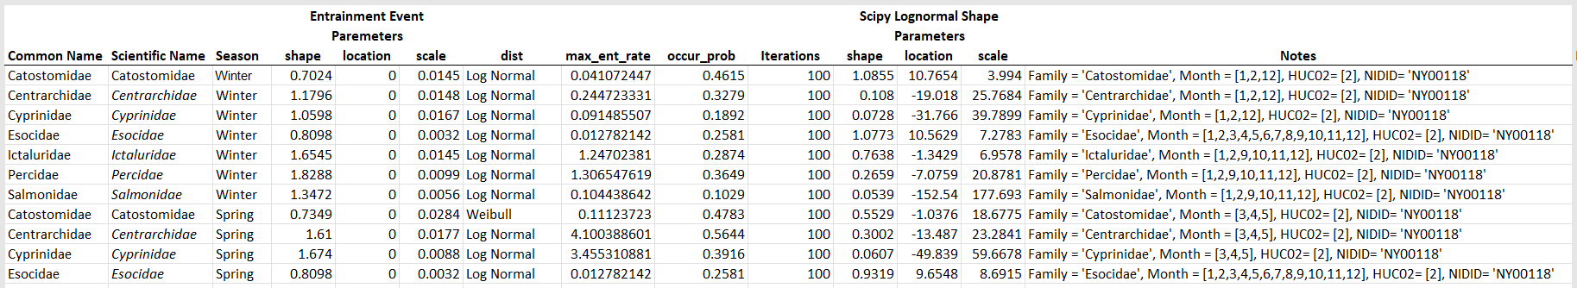
Note: The following columns have been hidden: Starting Population, Length_mean, Length_sd, and caudal_AR. The remaining columns depict a resident species set up.

Example Workflow #1: Station 1

Step 1: Create New Project.
This step tracks information about the project, including model setup. There are four model setup scenarios:
- Specified single unit, survival only
- Specified single unit, simulated entrainment with survival, no movement
- Single powerhouse with movement, simulated entrainment with survival
- Multiple dependent powerhouses with movement, simulated entrainment with survival
For the first two model setups, the only model location is the unit itself, therefore every fish that is simulated is routed through the unit. The first option (survival only) solely calculates blade strike mortality. The second option simulates fish passage through a unit while also incorporating simulations of entrainment probability. For option 3, (the single powerhouse), fish ‘follow the flow’ and are routed through or around the generating station as may be the case for sites that have spillways or other structures. Option 4 allows users to simulate complex fish passage through multiple powerhouses and spillways where probabilities of fish interactions and mortalities are compounded.
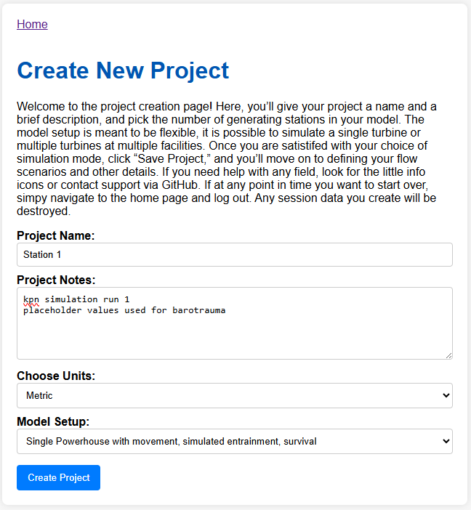
Figure 1 Create new project step, once satisfied press create project.

Step 2: Flow Scenarios
The website only allows for 1 flow scenario or season and 1 species. For this step, we will choose Hydrograph as the Scenario Type and then enter a scenario name, number and season designation. The number is arbitrary and is a holdover from the spreadsheet. Then, simply copy and paste the seasonal hydrograph data from a spreadsheet.
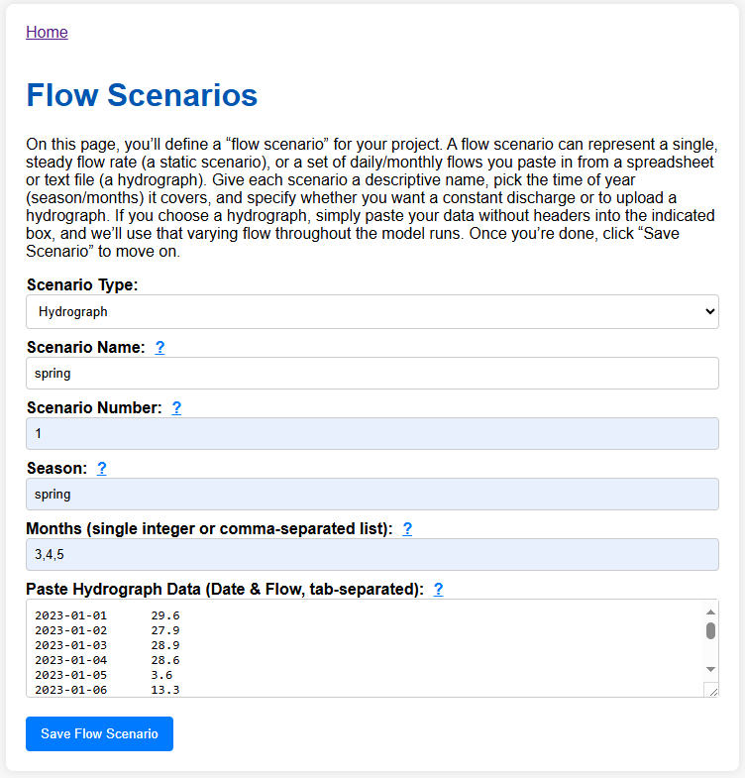
Figure 2 Flow scenarios page. Don’t enter the hydrograph by hand, copy and paste from a spreadsheet. Once satisfied click Save Flow Scenario.

Step 3: Facilities
The facilities page contains information about the facilities in the simulation, i.e. the generating stations. There are multiple fields on this form that become un-editable depending upon the modeling scenario you set up in the previous step. For our choice, we have the ability to alter the number of units, however there can only be 1 facility. For Station 1, there is only 1 unit. Note the blue question marks, hover over them for more information. Once you are satisfied with your choices, press Save Facilities and move on to the next step.
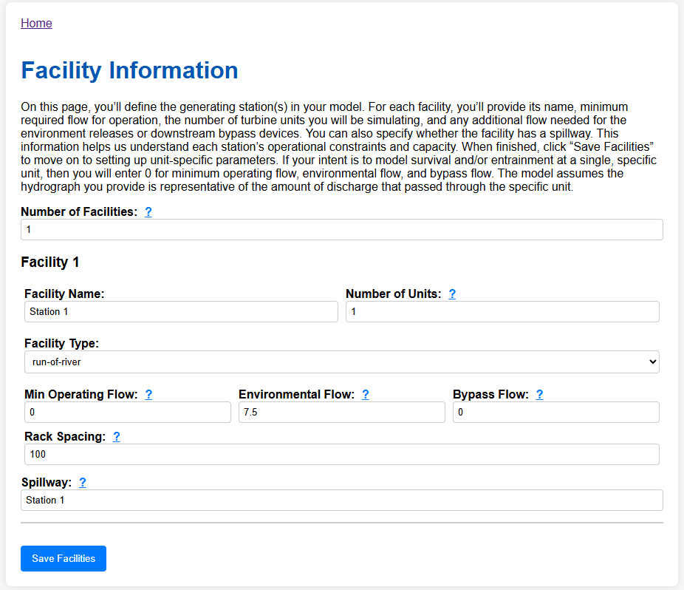
Figure 3 Facilities page with data for Station 1.

Step 4: Unit Parameters
You will enter unit parameters on this page. Depending upon the number of units indicated on the previous page, you may or may not see multiple Station – Unit controls. Expand on the first and enter information for Station 1 (see figure below). You will note three boxes. The top left describes basic unit parameters, like the type of runner and through-rack intake velocity (note we split the difference). The bottom left box contains parameters for the Barotrauma model. All units are in meters. If the model has more than 1 unit, subsequent units have an option to import parameters from the previous unit. If they are identical units, you will only have to enter data once as you can click the blue “Copy From Previous Unit” button to populate the field in the subsequent units using the data from the previous unit.
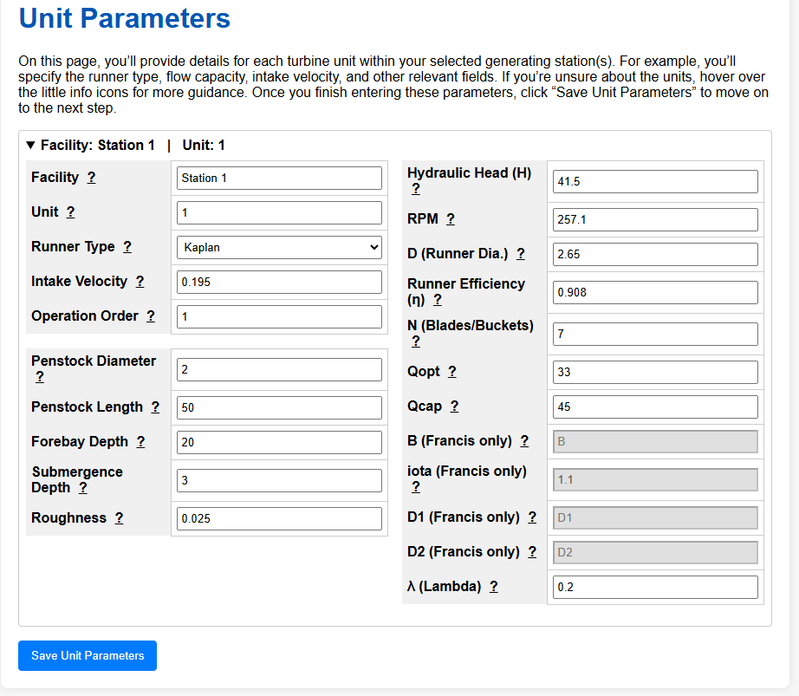
Figure 4 Unit parameters page containing information on the type of unit and its specifications.

Step 5: Operating Scenarios
The operating scenarios page contains data on how each unit is operated. For Run of River facilities, the end user has the ability to enter the number of hours each unit is operated per day. However, the form will change depending upon the number of units in the simulation and the type of operation. Peaking and Pumped Storage facilities have the ability to model for a set number of hours per day or simulated with a distribution fit to actual operations data. For Station 1, we have 1 unit operating 24 hours per day.
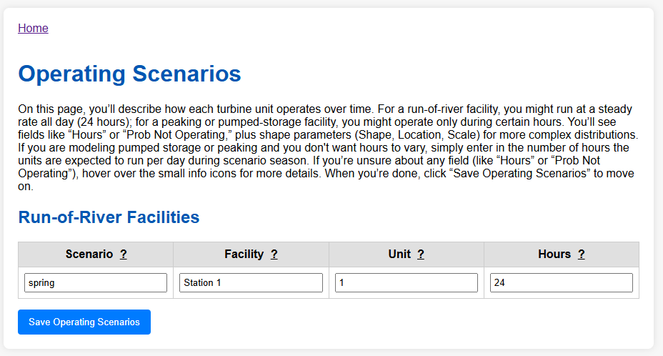

Step 6: Migratory Route Creation
This step is fun, interactive, and requires a bit of artistic expression. It has to be though, because every hydroelectric generating station is different and we need a model that is flexible enough to handle all of them. This page creates the migratory route that all simulated fish will move through during the simulation. All models, with the exception of Single Specified Unit models require a Start Node and an End Node. For a single specific unit model, simply choose the unit from the Add Unit Node button and accept defaults.
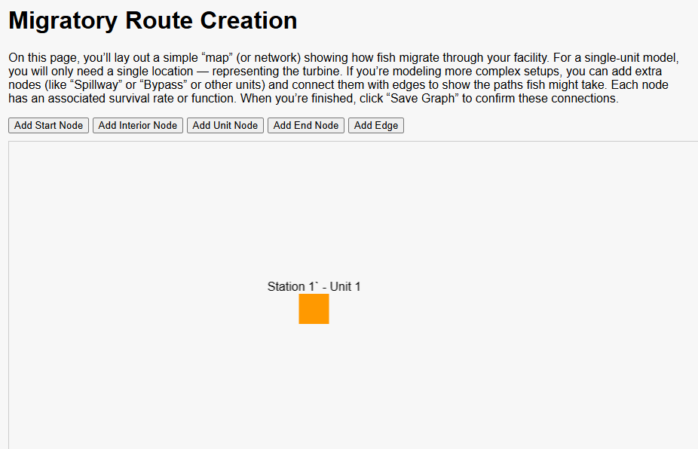
Figure 5 Migratory Route Creation. The Station 1 model has 4 nodes, our two required, and then two more for the places in our model we will be simulating survival. Note movement is upstream to downstream. Make sure you save the graph before moving on!

Step 7: Population Parameters
This is another large form with a lot of information. However, many fields are entered with pull down lists. In this model, we will simulate the genus Catostomus. Note we have two unfamiliar fields, Vertical Habitat, and Swim Bladder Type. Our species of interest are benthic with a physoclistous swim bladder. Next, we will choose to simulate an Entrainment Event with Modeled Rates. Once those choices are made, the end user can choose among a library of pre fit entrainment rates. The end user could enter their own distributions should they choose. Note, there is also a field for Ucrit, which is required to assess impingement risk. You can turn to Katapodis and Gervais (2012) for an appropriate measure for your species.
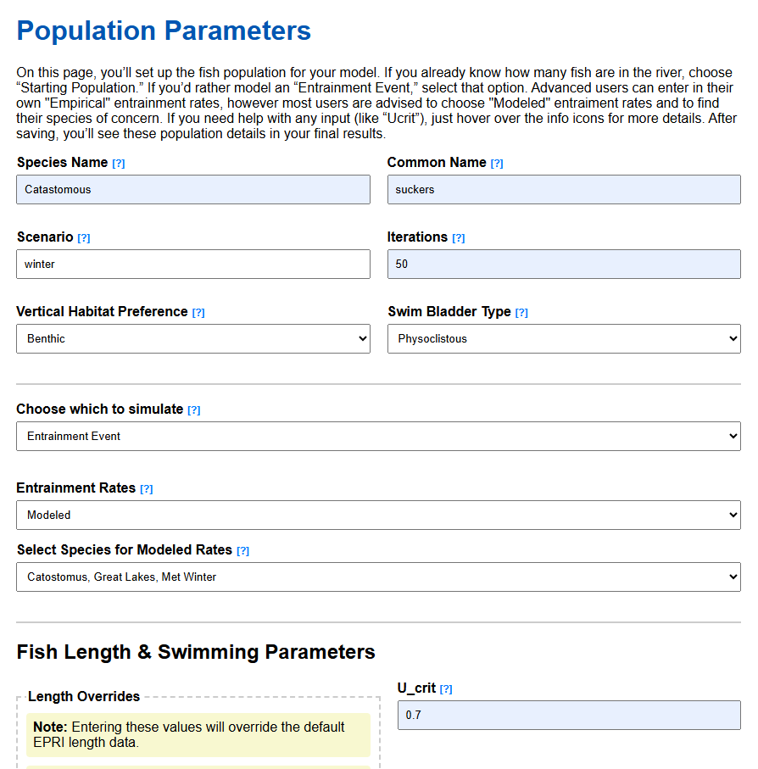
Figure 6 population parameters for the model simulating the genus Catostomus in winter at Station 1.

Step 7: Model Setup Summary
There is no data entry required on this page, but it is suggested that you expand each tab and examine the information entered into the forms. If you are unhappy with any choices, hit the Edit button to go back to the page. Once satisfied, press the big red button.
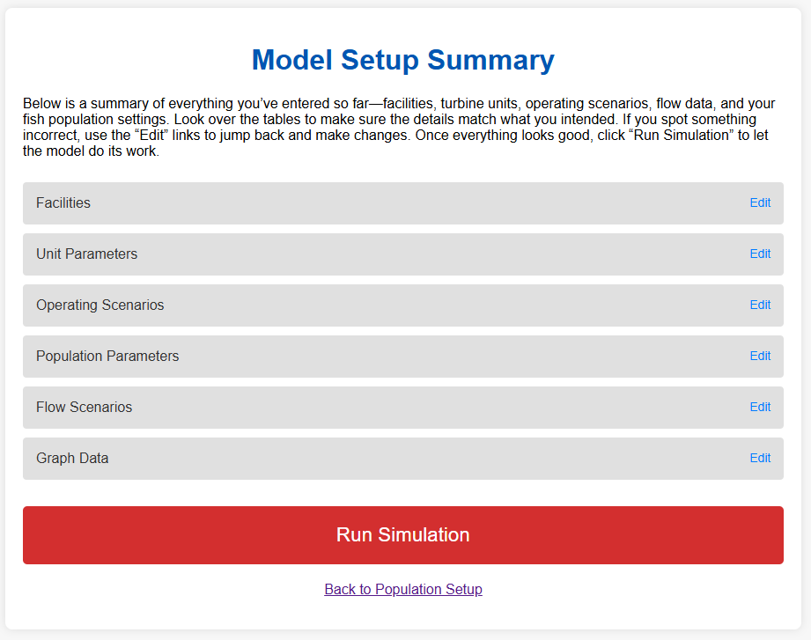
Figure 7 when you are satisfied with your model entries, press the big red button

Step 8: Simulation Progress
The only thing you need to do is sit back and watch the iterations go by. The simulation we just set up should take about 5 minutes to run. Once complete, there will be some text output, and a button to view the final results. Should something go wrong during a simulation, an error message will appear. Please take a screenshot and send it to kevin.nebiolo@kleinschmidt.com . Note, depending upon your station’s discharge and species of interest, large populations can be simulated. This will affect run time. If you see “…waiting for logs”, there is a large population. If you feel like it is stuck, send to kevin.nebiolo@kleinschmidt.com and I can diagnose the issue from the back end. But note, some iterations may take considerable time.
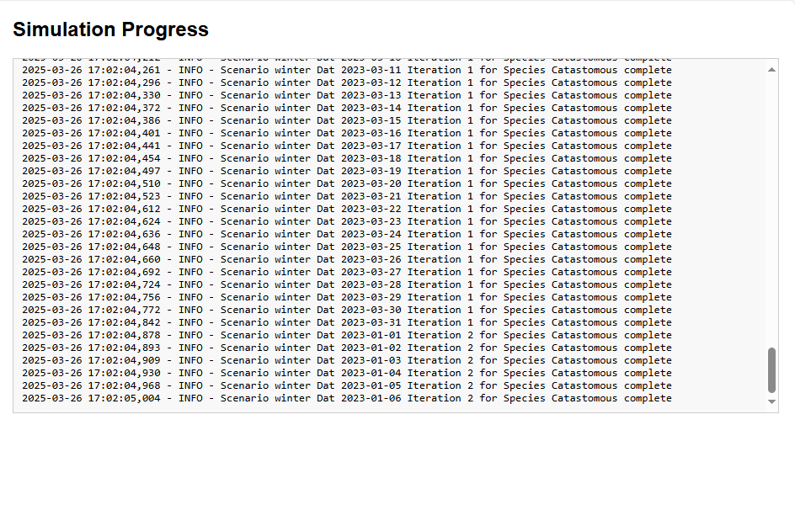
Figure 8 Simulation progress page during a simulation. When complete you will

Step 9: Examine Results
We simulated the worst-case scenario, a benthic acclimated genus with a physoclistous swim bladder that experiences latent mortality events. Feel free to right click and save as on any graphic. There is a download report button on the bottom left of the page, press that and you will get a zip file that contains all data that was created during your session. And remember, when you are done, click on the link to the home page at the top of the report and logout. This will empty out your session data by logging out and eliminate the chance that data from prior simulations will corrupt future simulations.
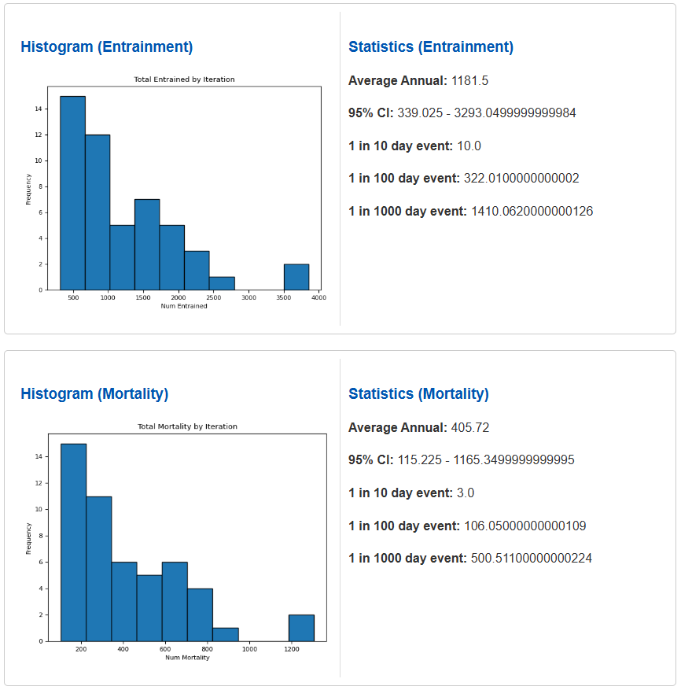
Figure 9 highlight of the results page.

Example Workflow #2: Coniston

Step 1: Create New Project.
This step tracks information about the project, including model setup. There are four model setup scenarios:
- Specified single unit, survival only
- Specified single unit, simulated entrainment with survival, no movement
- Single powerhouse with movement, simulated entrainment with survival
- Multiple dependent powerhouses with movement, simulated entrainment with survival
For the first two model setups, the only model location is the unit itself, therefore every fish that is simulated is routed through the unit. For the single powerhouse and multiple powerhouses setups, fish ‘follow the flow’ and are routed through or around the generating station.
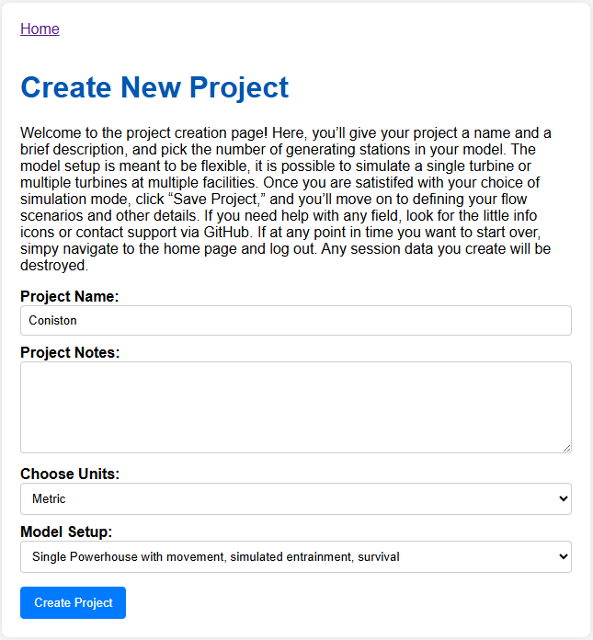
Figure 10 Create new project step, once satisfied press create project.

Step 2: Flow Scenarios
The website only allows for 1 flow scenario or season and 1 species. For this step, we will choose Hydrograph as the Scenario Type and then enter a scenario name, number and season designation. The number is arbitrary and is a holdover from the spreadsheet. Then, simply copy and paste the hydrograph data from a spreadsheet. Note, you can paste the entire year, it doesn’t need to correspond to your modeled season.
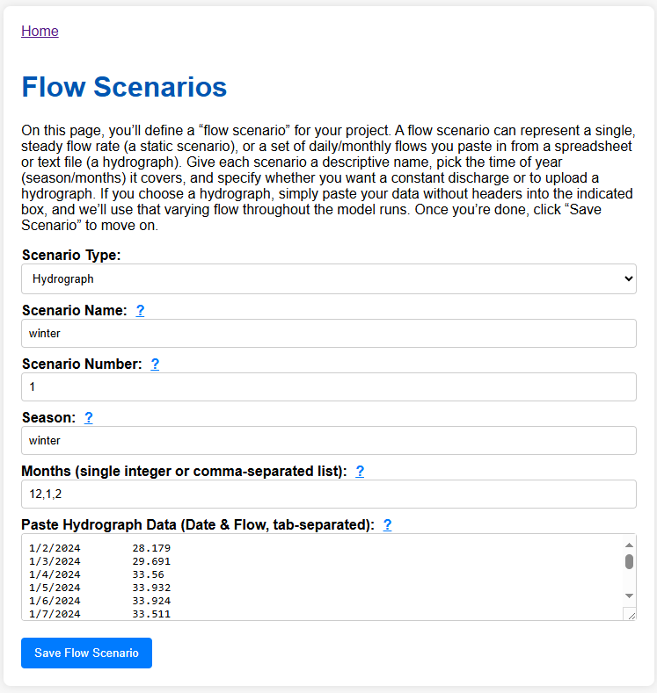
Figure 11 Flow scenarios page. Don’t enter the hydrograph by hand, copy and paste from a spreadsheet. Once satisfied click Save Flow Scenario.

Step 3: Facilities
The facilities page contains information about the facilities in the simulation, i.e. the generating stations. There are multiple fields on this form that become un-editable depending upon the modeling scenario you set up in the previous step. For our choice, we have the ability to alter the number of units, however there can only be 1 facility. For Station 1, there is only 1 unit. Note the blue question marks, hover over them for more information. Once you are satisfied with your choices, press Save Facilities and move on to the next step.
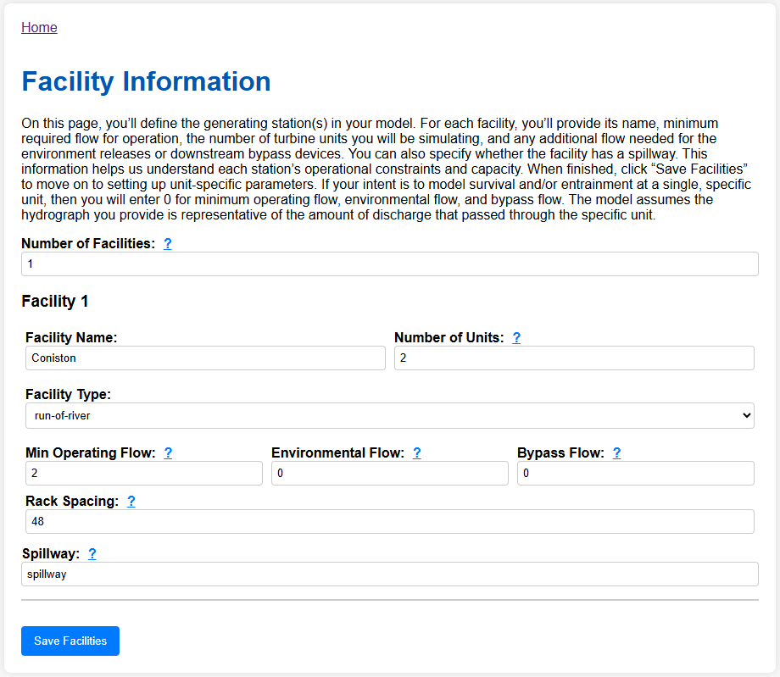
Figure 12 Facilities page with data for Station 1.

Step 4: Unit Parameters
You will enter unit parameters on this page. Depending upon the number of units indicated on the previous page, you may or may not see multiple Station – Unit controls. Expand on the first and enter information for Station 1 (see figure below). You will note three boxes. The top left describes basic unit parameters, like the type of runner and intake velocity (note we split the difference). The bottom left box contains parameters for the Barotrauma model. All units are in meters. If the model has more than 1 unit (in this example we have 2), subsequent units have an option to import parameters from the previous unit. If they are identical units, you can click on the blue “Copy From Previous Unit” button to automatically populate the fields in the subsequent unit using the data from the previous unit.
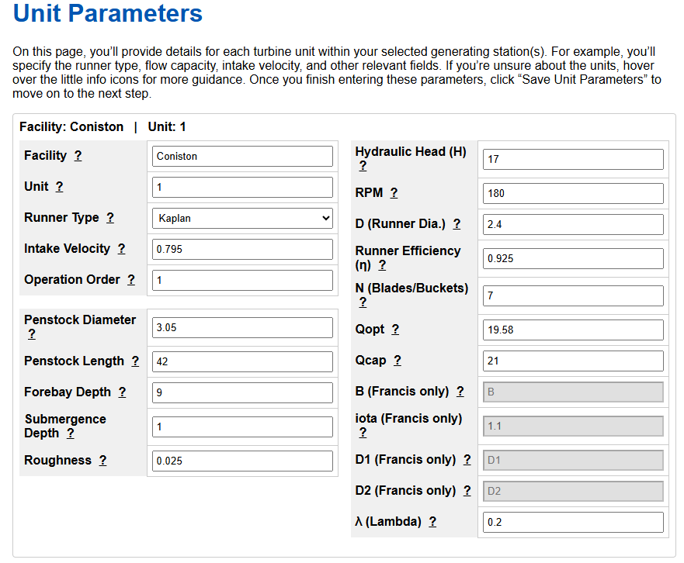
Figure 13 Unit parameters page containing information on the type of unit and its specifications.

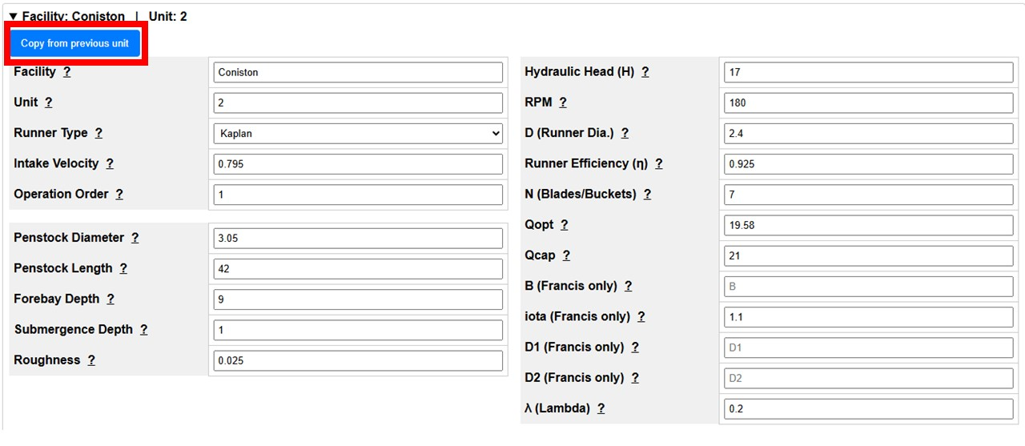
Figure 14 Unit parameters page containing information on the type of unit and its specifications Copied from the first unit using the blue “Copy From Previous Unit” button outlined here in red.

Step 5: Operating Scenarios
The operating scenarios page contains data on how each unit is operated. For Run of River facilities, the end user has the ability to enter the number of hours each unit is operated per day. However, the form will change depending upon the number of units in the simulation and the type of operation. Peaking and Pumped Storage facilities have the ability to model for a set number of hours per day or simulated with a distribution fit to actual operations data. For Station 1, we have 1 unit operating 24 hours per day.
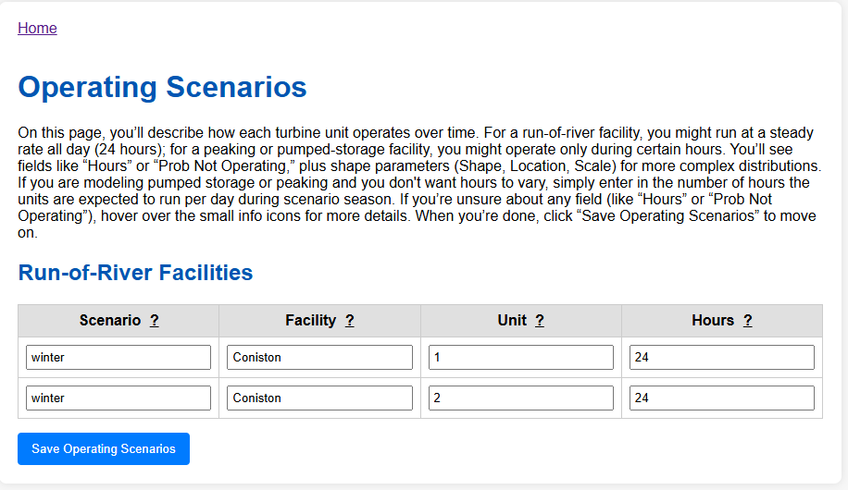

Step 6: Migratory Route Creation
This step is fun, interactive, and requires a bit of artistic expression. It has to be though, because every hydroelectric generating station is different, and we need a model that is flexible enough to handle all of them. This page creates the migratory route that all simulated fish will move through during the simulation. All models, with the exception of Single Specified Unit models require a Start Node and an End Node. Note, you have two buttons for those location types. The Start Node is a green circle while the End Node is a red octagon. Take the defaults and press ok. Then we have the ability to add an interior node and a unit node. Interior nodes are every place in your migratory network that you want to model – other than a turbine runner. For our example, we have entered spillway and accepted the defaults. Then, we added a Unit Node. We only have one unit, but we need to grab it from the drop down as well as choose a unit type. In this case Kaplan. Finally we add Edges. Edges will always move from the Start Node to the End Node. Note that the spillway and Unit 1 are between the Start and End. Therefore, the first Edge will connect the Start Node to the Spillway. You do so by first clicking on the Start Node and then the spillway node. Then we will create an edge from the Start Node to Unit 1. Next, we need to create two more edges connecting the spillway to the End Node and Unit 1 to the End Node. If you made a mistake, you can click on objects and delete them with the delete key. There is no limit to the amount of nodes and edges in your simulation, but they must make sense and always be oriented downstream.
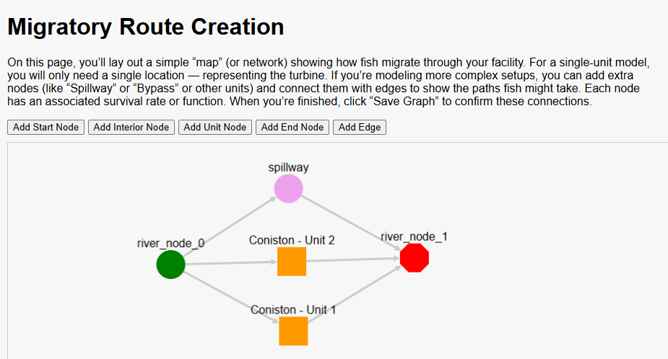
Figure 5 Migratory Route Creation. The Station 1 model has 4 nodes, our two required, and then two more for the places in our model we will be simulating survival. Note movement is upstream to downstream. Make sure you save the graph before moving on!

Step 7: Population Parameters
This is another large form with a lot of information. However, many fields are entered with pull down lists. In this model, we will simulate the genus Catostomus. Note we have two unfamiliar fields, Vertical Habitat, and Swim Bladder Type. Our species of interest are benthic with a physoclistous swim bladder. Next, we will choose to simulate an Entrainment Event with Modeled Rates. Once those choices are made, the end user can choose among a library of pre fit entrainment rates. The end user could enter their own distributions should they choose. Note, there is also a field for Ucrit, which is required to assess impingement risk. You can turn to Katapodis and Gervais (2012) for an appropriate measure for your species.
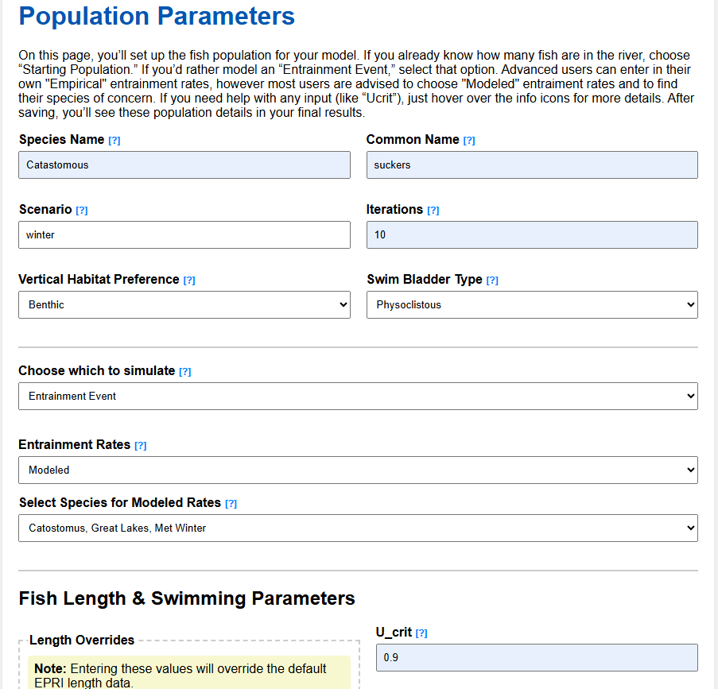
Figure 16 population parameters for the model simulating the genus Catostomus in winter at Station 1.

Step 7: Model Setup Summary
There is no data entry required on this page, but it is suggested that you expand each tab and examine the information entered into the forms. If you are unhappy with any choices, hit the Edit button to go back to the page. Once satisfied, press the big red button.
Figure 17 when you are satisfied with your model entries, press the big red button

Step 8: Simulation Progress
The only thing you need to do is sit back and watch the iterations go by. The simulation we just set up should take about 5 minutes to run. Once complete, there will be some text output, and a button to view the final results. Should something go wrong during a simulation, an error message will appear. Please take a screenshot and send it to kevin.nebiolo@kleinschmidt.com . Note, depending upon your station’s discharge and species of interest, large populations can be simulated. This will affect run time. If you see “…waiting for logs”, there is a large population. If you feel like it is stuck, send to kevin.nebiolo@kleinschmidt.com and I can diagnose the issue from the back end. But note, some iterations may take considerable time.
Figure 18 Simulation progress page during a simulation. When complete you will

Step 9: Examine Results
We simulated the worst-case scenario, a benthic acclimated genus with a physoclistous swim bladder that experiences latent mortality events. Feel free to right click and save as on any graphic. There is a download report button on the bottom left of the page, press that and you will get a zip file that contains all of the data that was created during your session. And remember, when you are done, click on the link to the home page at the top of the report and logout. This will empty out your session data and eliminate the chance that data from prior simulations will corrupt future simulations.
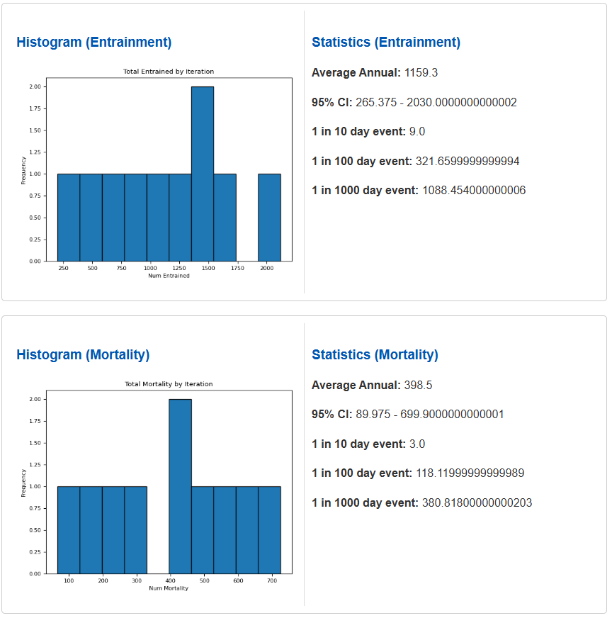
Figure 9 highlight of the results page.

